PROJECT :- HOSPITAL MANAGEMENT

**Project Overview: Hospital Management System**

**Introduction:** The Hospital Management System (HMS) is designed to streamline various administrative and clinical processes within a healthcare facility. It encompasses managing patient records, scheduling appointments, tracking prescriptions, handling billing information, and maintaining inventory of medicines and equipment.

**Database Structure:**

1. **Patients Table:** Stores essential information about patients including their ID, name, gender, date of birth, contact details, email, address, and insurance ID.
2. **Doctors Table:** Contains details about doctors such as their ID, name, gender, date of birth, contact information, email, specialization, and workdays.
3. **Staff Table:** Records data of the hospital staff including their ID, name, gender, date of birth, contact details, email, and role within the hospital.
4. **Appointments Table:** Manages appointments between patients and doctors, storing information such as appointment ID, patient ID, doctor ID, appointment date and time, and appointment status.
5. **Prescriptions Table:** Tracks prescriptions given to patients by doctors, recording prescription ID, patient ID, doctor ID, medications prescribed, dosage, instructions, and date prescribed.
6. **Billing Information Table:** Handles billing details of patients, storing bill ID, patient ID, total amount, payment status, and billing date.
7. **Inventory Medicines Table:** Manages the inventory of medicines available in the hospital, including details such as medicine ID, name, batch number, expiration date, quantity available, and price per unit.
8. **Inventory Equipment Table:** Keeps track of hospital equipment inventory, recording equipment ID, name, purchase date, maintenance date, and availability status.

**Functionalities:**

1. **Patient Management:** Allows the addition, retrieval, update, and deletion of patient records. It facilitates efficient management of patient data including demographics, contact information, and insurance details.
2. **Doctor Management:** Enables the management of doctor information, including specialization and work schedule. It assists in assigning doctors to appointments based on their availability and expertise.
3. **Staff Management:** Facilitates the management of hospital staff records, including their roles and responsibilities within the organization.
4. **Appointment Scheduling:** Enables patients to schedule appointments with doctors based on their availability. It helps in organizing and managing the patient flow within the hospital.
5. **Prescription Tracking:** Tracks prescriptions given to patients, ensuring accurate medication records and adherence to treatment plans.
6. **Billing Management:** Manages the billing process, including generating bills for services rendered, tracking payment status, and maintaining billing history.
7. **Inventory Management:** Tracks inventory levels of medicines and equipment, ensuring adequate supply and efficient utilization of resources.

**Conclusion:** The Hospital Management System provides a comprehensive solution for managing various aspects of hospital operations, improving efficiency, accuracy, and patient care delivery. By centralizing and automating administrative and clinical processes, it helps healthcare facilities enhance their overall performance and service quality.

create database HospialManagement1;

use HospialManagement1;

CREATE TABLE Patients (

PatientID INT PRIMARY KEY,

FirstName VARCHAR(255),

LastName VARCHAR(255),

Gender CHAR(1),

DateOfBirth DATE,

ContactNumberVARCHAR(15),

Email VARCHAR(255),

Address TEXT,

InsuranceIDVARCHAR(50)

);

CREATE TABLE Doctors (

DoctorID INT PRIMARY KEY,

FirstName VARCHAR(255),

LastName VARCHAR(255),

Gender CHAR(1),

DateOfBirth DATE,

ContactNumberVARCHAR(15),

Email VARCHAR(255),

Specialization VARCHAR(255),

WorkDaysVARCHAR(255)

);

CREATE TABLE Staff (

StaffID INT PRIMARY KEY,

FirstName VARCHAR(255),

LastName VARCHAR(255),

Gender CHAR(1),

DateOfBirth DATE,

ContactNumberVARCHAR(15),

Email VARCHAR(255),

Role VARCHAR(50)

);

CREATE TABLE Appointments (

AppointmentID INT PRIMARY KEY,

PatientID INT,

DoctorID INT,

AppointmentDateTime DATETIME,

Status VARCHAR(50),

FOREIGN KEY (PatientID) REFERENCES Patients(PatientID),

FOREIGN KEY (DoctorID) REFERENCES Doctors(DoctorID)

);

CREATE TABLE Prescriptions (

PrescriptionID INT PRIMARY KEY,

PatientID INT,

DoctorID INT,

Medications TEXT,

Dosage TEXT,

Instructions TEXT,

DatePrescribed DATE,

FOREIGN KEY (PatientID) REFERENCES Patients(PatientID),

FOREIGN KEY (DoctorID) REFERENCES Doctors(DoctorID)

);

CREATE TABLE BillingInformation (

BillID INT PRIMARY KEY,

PatientID INT,

TotalAmountDECIMAL(10, 2),

PaymentStatusVARCHAR(50),

BillingDate DATE,

FOREIGN KEY (PatientID) REFERENCES Patients(PatientID)

);

CREATE TABLE InventoryMedicines (

MedicineID INT PRIMARY KEY,

MedicineNameVARCHAR(255),

BatchNumberVARCHAR(50),

ExpirationDate DATE,

QuantityAvailable INT,

PricePerUnitDECIMAL(10, 2)

);

CREATE TABLE InventoryEquipment (

EquipmentID INT PRIMARY KEY,

EquipmentNameVARCHAR(255),

PurchaseDate DATE,

MaintenanceDate DATE,

AvailabilityStatusVARCHAR(50)

);

INSERT INTO Patients (PatientID, FirstName, LastName, Gender, DateOfBirth, ContactNumber, Email, Address, InsuranceID)

VALUES

(1, 'John', 'Doe', 'M', '1985-05-15', '1234567890', 'john.doe@example.com', '123 Main St Cityville', 'INS123'),

(2, 'Alice', 'Smith', 'F', '1990-02-20', '9876543210', 'alice.smith@example.com', '456 Elm St Townsville', 'INS456'),

(3,'tanmay','sharnagat','M','2013-03-03','9165845678','tanmay@gmail.com','indore','INS345'),

(4,'priya','sharnagat','F','2003-03-03','9165843678','priya@gmail.com','katangi','INS346'),

(5,'pragya','dawar','F','2004-03-13','9325845678','pragya@gmail.com','barwani','INS347');

INSERT INTO Doctors (DoctorID, FirstName, LastName, Gender, DateOfBirth, ContactNumber, Email, Specialization, WorkDays)

VALUES

(1, 'Dr. Robert', 'Johnson', 'M', '1978-10-10', '111-222-3333', 'robert.johnson@gmail.com', 'Cardiologist', 'Mon, Wed, Fri'),

(2, 'Dr. Emily', 'Williams', 'F', '1982-07-05', '444-555-6666', 'emily.williams@gmail.com', 'Pediatrician', 'Tue, Thu, Sat'),

(3, 'Dr. Shaili', 'Sharnagat', 'F', '2004-11-05', '123-555-6666', 'shaili@gmail.com', 'EyeSpecialist', 'Mon, Thu, Sat'),

(4, 'Dr. Ayushi', 'Dawar', 'F', '2003-07-05', '176-145-6666', 'ayushi@gmail.com', 'Physiologist', 'Tue, wed, Sat'),

(5, 'Dr. Niharika', 'Memoroth', 'F', '2005-03-11', '444-555-1234', 'Niharika@gmail.com', 'Neurologist', 'Tue, fri, Sat');

;

INSERT INTO Staff (StaffID, FirstName, LastName, Gender, DateOfBirth, ContactNumber, Email, Role)

VALUES

(1, 'Tanushree', 'Dhote', 'F', '2003-06-06', '777-888-9999', 'tanushree@example.com', 'Nurse'),

(2, 'Anxiety', 'kumar', 'M', '2005-09-12', '111-333-5555', 'anxiety@example.com', 'receptionist'),

(3, 'ankit', 'Bhaskar', 'M', '2001-06-02', '222-333-5555', 'Aditya@example.com', 'Swipper'),

(4, 'Vikash', 'gupta', 'M', '2004-09-12', '1999-234-5555', 'Vikash@example.com', 'guard'),

(5, 'jayas', 'mahore', 'M', '2002-11-12', '934-333-5555', 'jayas@example.com', 'Receptionist');

INSERT INTO Appointments (AppointmentID, PatientID, DoctorID, AppointmentDateTime, Status)

VALUES

(1, 1, 1, '2023-10-15 10:00:00', 'Scheduled'),

(2, 2, 2, '2023-10-16 14:30:00', 'pending'),

(3, 3, 3, '2023-10-17 11:35:00', 'Scheduled'),

(4, 4, 4, '2023-10-18 10:00:00', 'pending'),

(5, 5, 5, '2023-10-19 16:00:00', 'Scheduled');

INSERT INTO Prescriptions (PrescriptionID, PatientID, DoctorID, Medications, Dosage, Instructions, DatePrescribed)

VALUES

(1, 1, 1, 'Lisinopril', '10mg', 'Take once daily', '2023-10-15'),

(2, 2, 2, 'Albuterol', '2 puffs', 'As needed for wheezing', '2023-10-16'),

(3, 3, 3, 'surgery', '1mg', 'thrice once daily', '2024-01-01'),

(4, 4, 4, 'taltz','10mg',' daily', '2023-11-11'),

(5, 1, 1, 'cynopril', 'mg', 'Take once daily', '2023-10-15');

INSERT INTO BillingInformation (BillID, PatientID, TotalAmount, PaymentStatus, BillingDate)

VALUES

(1, 1, 150.00, 'Paid', '2023-10-15'),

(2, 2, 200.00, 'Unpaid', '2000-10-16'),

(3, 2, 330.00, 'paid', '2003-11-24'),

(4, 4, 019.00, 'Unpaid', '2004-05-16'),

(5, 1, 201.00, 'Unpaid', '2006-12-03');

INSERT INTO InventoryMedicines (MedicineID, MedicineName, BatchNumber, ExpirationDate, QuantityAvailable, PricePerUnit)

VALUES

(1, 'Aspirin', 'ABC123', '2024-12-31', 500, 5.99),

(2, 'Amoxicillin', 'DEF456', '2023-11-30', 200, 8.75),

(3, 'paracuetamol', 'fd123', '1114-12-31', 640, 3.99),

(4, 'ativan', 'A13123', '2001-10-30', 120, 5.99),

(5, 'betadine', 'gdn143', '2009-12-30', 450, 2.99);

INSERT INTO InventoryEquipment (EquipmentID, EquipmentName, PurchaseDate, MaintenanceDate, AvailabilityStatus)

VALUES

(1, 'X-ray Machine', '2022-01-15', '2023-07-15', 'Available'),

(2, 'memograph Machine', '2034-01-15', '2033-12-24', 'Available'),

(3, 'Ultrasound Machine', '2021-09-20', '2023-09-20', 'In Use'),

(4, 'sterilizers Machine', '2022-01-23', '2023-12-15', 'unAvailable'),

(5, 'sonography Machine', '2034-12-15', '2003-07-05', 'in use');

select * from patients;

select * from Doctors

select * from Staff;

select * from Appointments;

select * from Prescriptions;

select * from BillingInformation;

select * from InventoryMedicines;

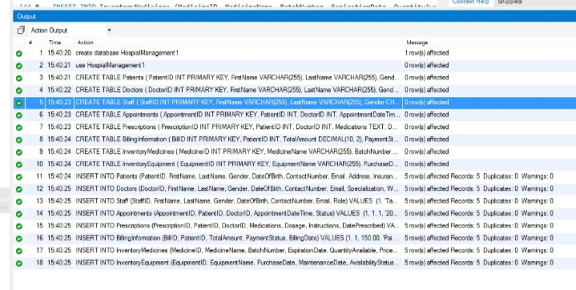

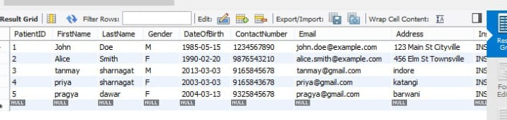

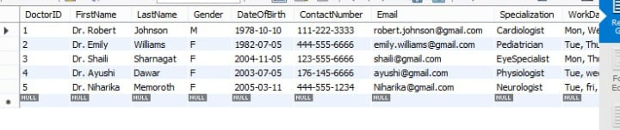

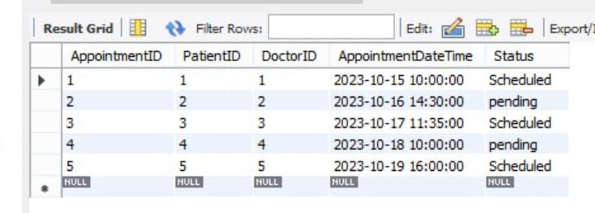

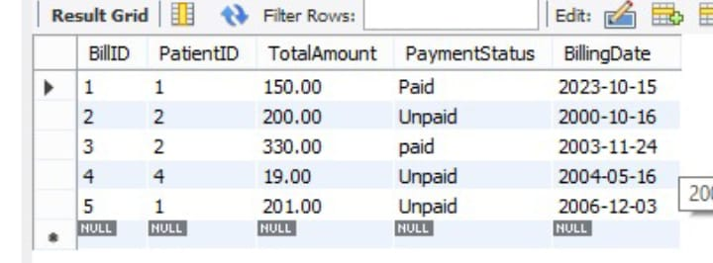

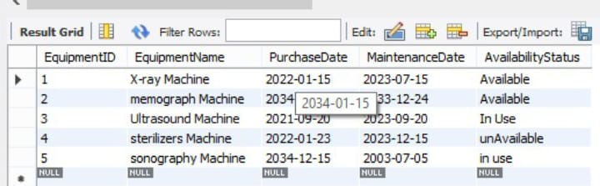

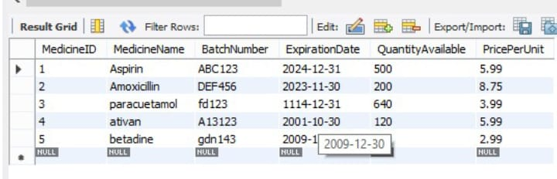

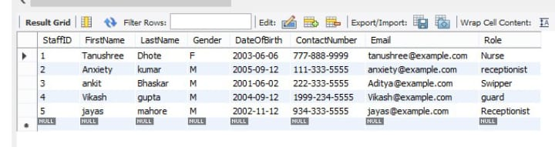

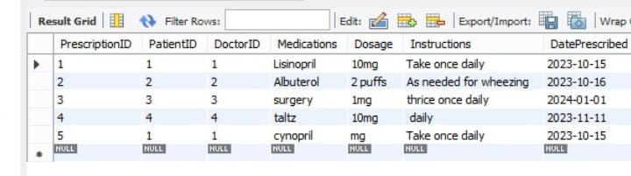

E-R DIAGRAM

